Full Robocode setup + Intellij setup instructions

Table of Contents

Install Robocode 1

Setup Development With Intellij 7

Open Intellij Project 7

Point Robocode to your Robot files 8

Setup Intellij Debugging 10

Tournament Rules 12

Robocode Rules 12

Scoring 13

Tournament bracket 14

Useful links 14

# Install Robocode

* Make sure you have java setup on your computer <https://robowiki.net/wiki/Robocode/System_Requirements>
  + Most people can skip this step, as Vault uses Java
* Download/clone this repo: <https://github.com/gerbilord/gvconnect_robocode>

git clone <https://github.com/gerbilord/gvconnect_robocode.git>

* Go the the repo folder, run the included jar "robocode-1.9.5.1-setup.jar"
  + You may see an error like, just run it anyways, its open source.
    - 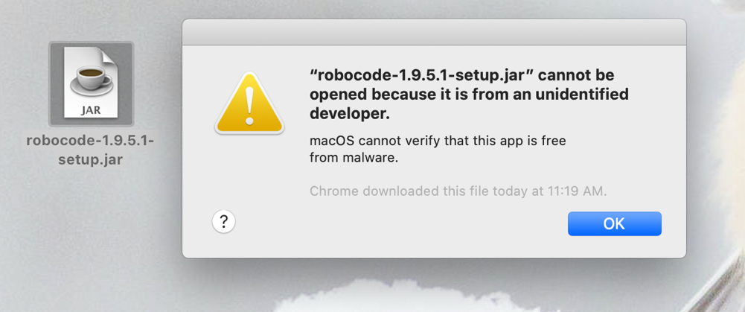
  + On mac you can get around this by control clicking the jar file, and hitting open
    - 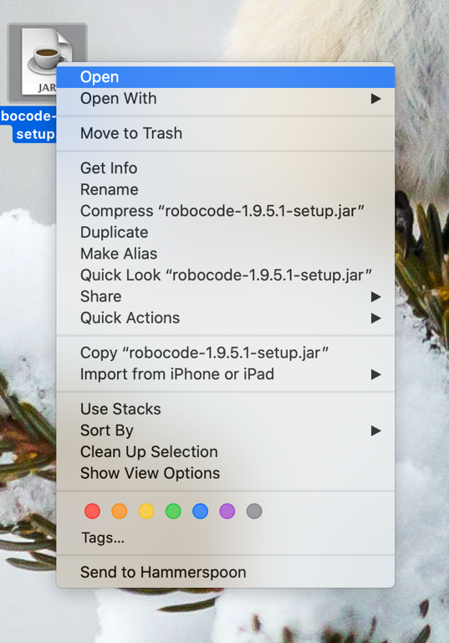
  + If you have trouble on windows, you may have to do something like this: <https://stackoverflow.com/questions/37105012/execute-jar-file-as-administrator-in-windows>
* Follow instructions to setup:
  + Select NO if you want a different setup path.
    - 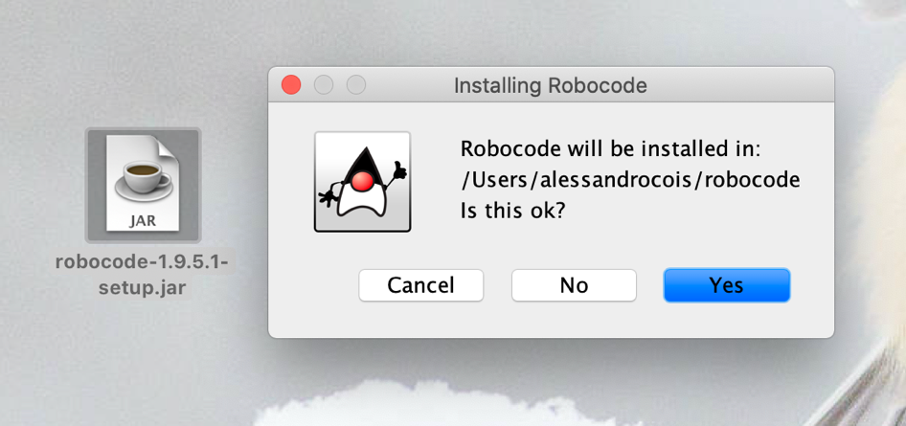
    - 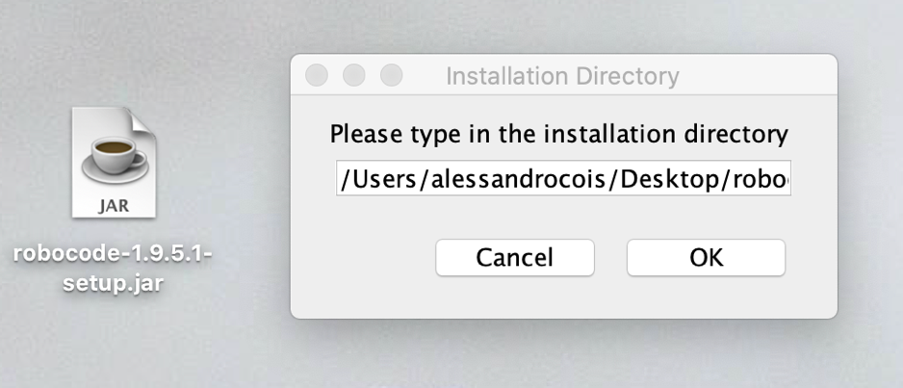
  + Follow the rest of the instructions, you should see success at the end if all went well.
    - 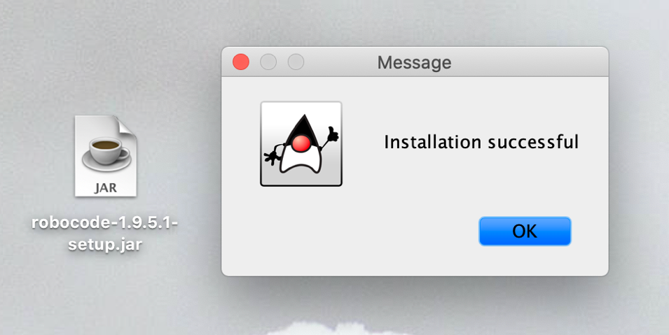
* On Mac: run robocode, by double clicking “robocode.sh”
  + - 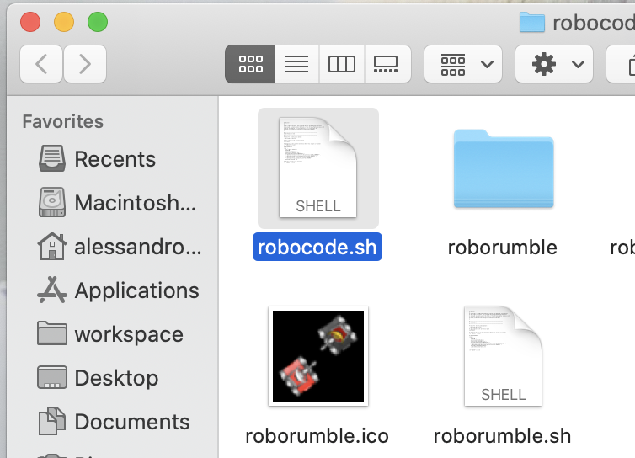
  + Alternatively, if that doesn’t work, you can run it from the terminal
    - 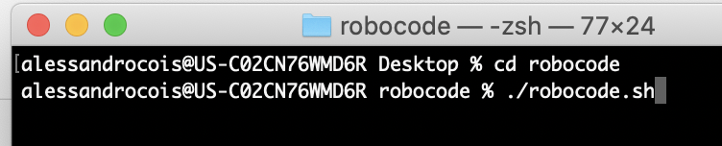
* On Windows: Run the “robocode.bat” file. You may need to open up a terminal to do that.
* You should see a splash screen, then the application pop up!
  + It will run a battle, in a window like this.
  + A screenshot of a computer

    Description automatically generated
* Run your first battle
  + Select Battle from the top menu, and click “New
    - 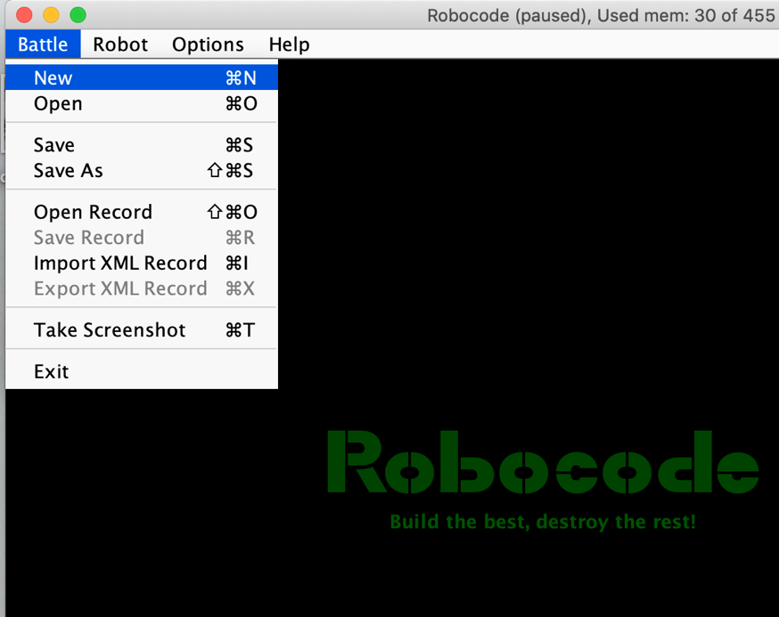
  + Add a few sample robots to your battle, then click start battle at the bottom!
    - A screenshot of a computer

      Description automatically generated
  + A battle should pop up and play out! Yay!
    - 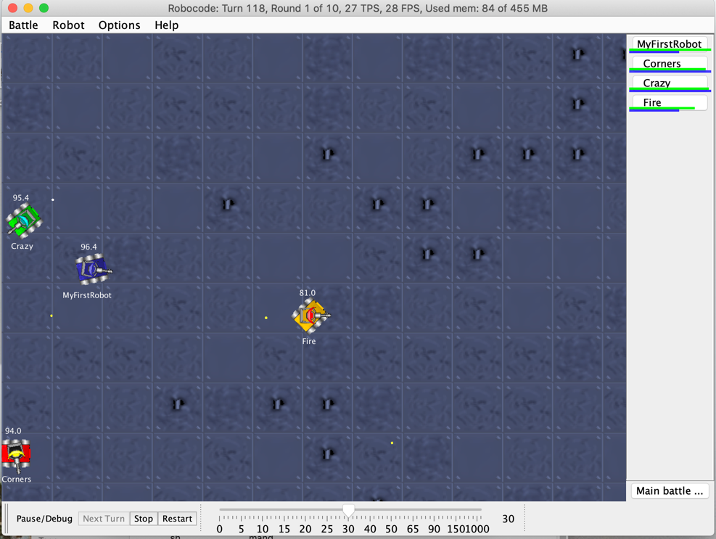

# Setup Development With Intellij

* If you do not care about debugging, autocomplete or your intellij hotkeys, you can use the built in editor. (Not recommended) See instructions here <https://robowiki.net/wiki/Robocode/My_First_Robot>

## Open Intellij Project

* In intellij, “open” a project. Select the folder “intellijDevelopment” located inside the git repo you cloned.
  + - A screenshot of a computer

      Description automatically generated

## Setup Robocode Libraries

* + Open module settings for your top folder
    - A screenshot of a computer

      Description automatically generated
  + Go to the libraries section, and add a “Java” library
    - A screenshot of a computer

      Description automatically generated
  + Add both the “Javadoc” and “libs” folder
    - A screenshot of a computer

      Description automatically generated
  + Your “Libraries” should look like this. (Don’t worry about Name).
    - A screenshot of a computer

      Description automatically generated
  + Your “Modules” should look like this
    - A screenshot of a computer

      Description automatically generated
  + Click Apply + Okay at the bottom.

## Build your project

* In your project, you should see src/gvconnect/team1_theKoolKidsBot
* Click the hammer “Build Project” (Compile your project).
* Verify you see “team1_theKoolKidsBot” in the out/production/robocodeIntellij/gvconnect folder
  + - A screenshot of a computer

      Description automatically generated

## Point Robocode to your Robot files

* In robocode, Go to options > preferences in the menu
  + - 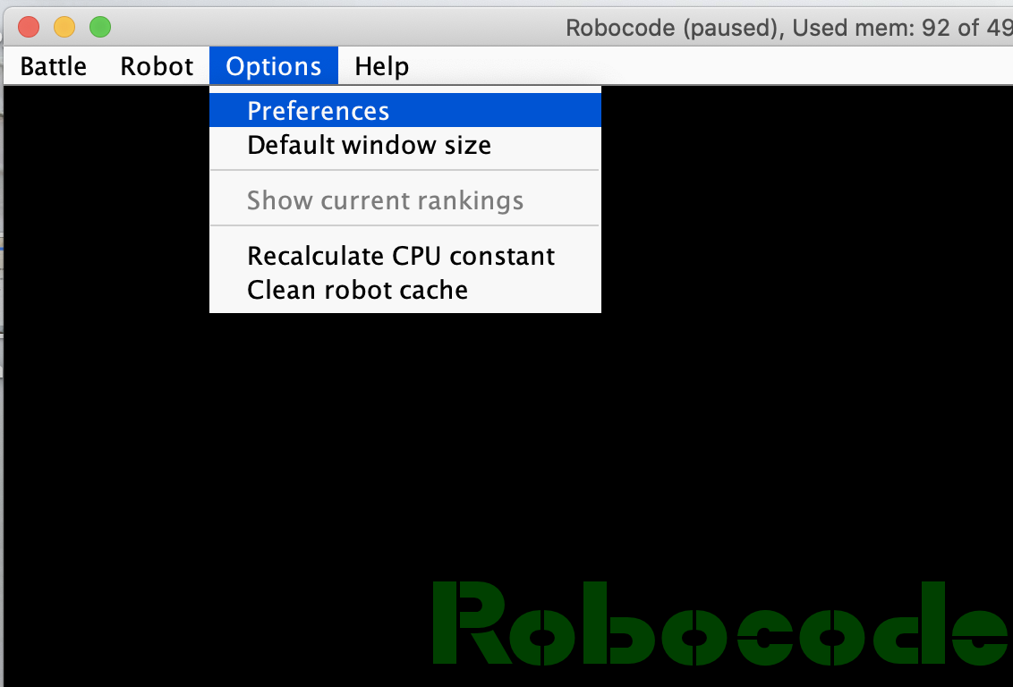
* In development options add path to: **…/gvconnect_robocode/intellijDevelopment/out/production/robocodeIntellij**
  + This exact path is very important. (If you point one folder too high or low it won’t work).
    - A screenshot of a computer

      Description automatically generated
* Hit finish and go create a new battle. After hitting Cmd + R, you should see your new bot! You can add it and battle with it.
  + A screenshot of a computer

    Description automatically generated
* You can now develop and test your robot.
* Make as many robots as you want. Make sure to rename your robots.
  + You can do this by adding another Robot file in the “gvconnect” package. (Where “team1_theKookKisBot” is located).

# Setup Intellij Debugging

* Close robocode. Intellij is going to open it later.
* In Intellij, you should already see a run configuration. We need to modify it. Hit “Edit Configurations”A screenshot of a computer

  Description automatically generated
* “working directory” must be changed to: path/where/you/installed/robocode (not the intellij project)
  + - 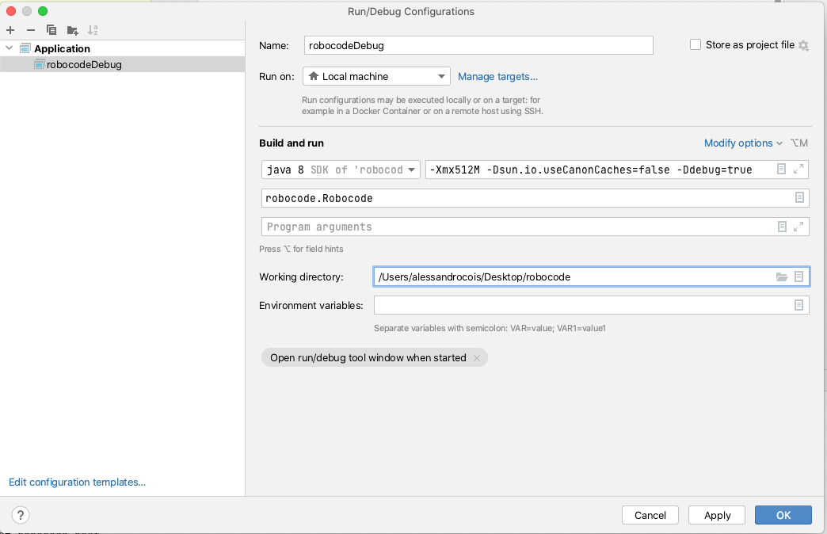
  + Take a second to verify the rest of your debug config matches the picture.
* Now add some breakpoints to your robot, then hit debug.
  + A screenshot of a computer

    Description automatically generated
* Robocode should pop up! Run a new battle with your robot, and a sample one.
* When the battle runs, and your bot code hits a breakpoint, the battle will pause and you can debug!
  + 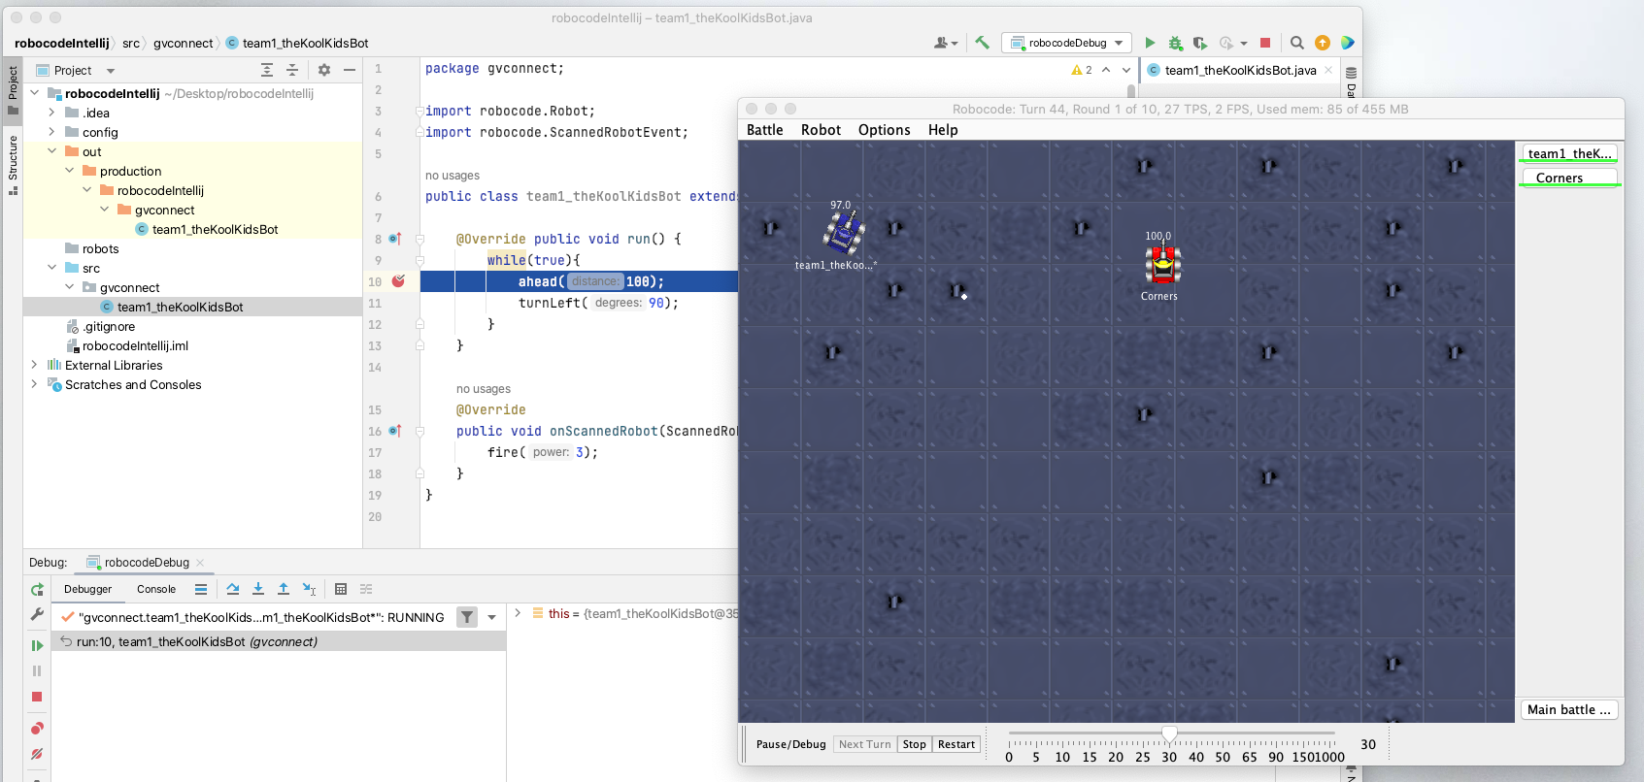

# Tournament Rules

## Robocode Rules

We will be having a melee tournament. Meaning bots will fight on a 1000x1000 grid, with 10 bots total on the screen.

<https://robowiki.net/wiki/Melee>

When creating a new battle, hit the rules tab at the top, set your board to 1000x1000 so you can test your bots in the correct space!

You also may want to set number of rounds to 1 for testing.

Leave the other rules as default.

Your robot may only extend “Robot” or “AdvancedRobot”.

Do not implement “BorderSentry” or “Droid”.

## Scoring

Scoring will be based on the “Total Score” at the end of the rounds. This can be seen in a pop-up once all rounds are over.

<https://robowiki.net/wiki/Robocode/Scoring>

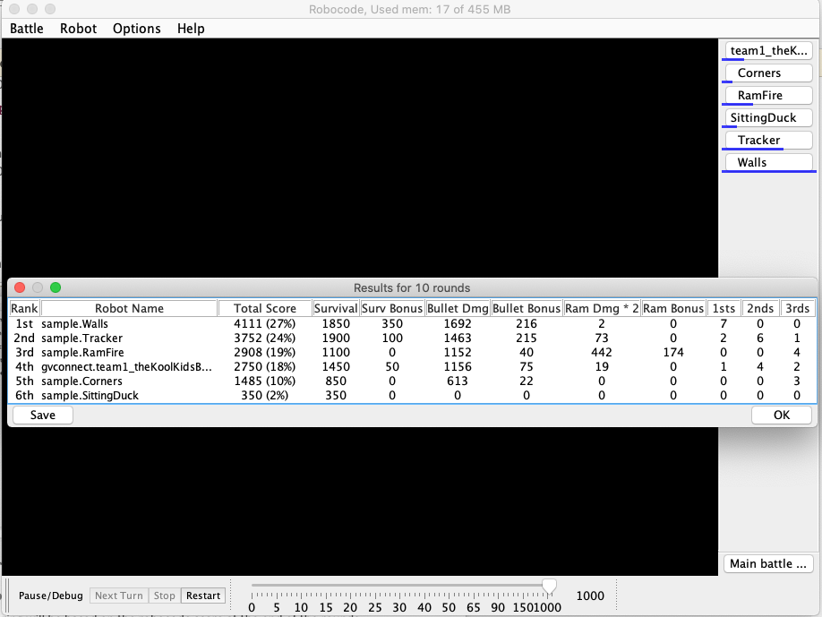

## Tournament bracket

There are 60 teams. 10 robots will fight at a time. There will be 6 winners in the first round.

Then we will fight those 6 winners against each other to decide our champion.

# Useful links

Start with -> Wiki FAQ - <https://robowiki.net/wiki/Robocode/FAQ>

API - <https://robocode.sourceforge.io/docs/robocode/>

Melee Strategy - <https://robowiki.net/wiki/Melee_Strategy>

Wiki home page - <https://robowiki.net/wiki/Main_Page>